**Name: Muhammad Ethisham**

**Roll Number: KWOWFL3434**

**Dart Test**

**Write a program to calculate the factorial of a given number.**

void main(List<String> args) {

int num1=5;

int fac=1;

for(int i=num1;i>=1;i--)

{

fac=i*fac;

}

print("Fatorial of $num1 = $fac");

}

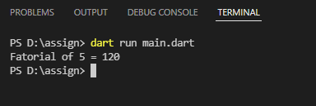

**Write a program to make such a pattern like a pyramid with a number**

**which will repeat the number in the same row.**

import 'dart:io';

void main() {

int i, j, numbers=1, n = 4;

for(i=0;i<n;i++){

for(j = 0; j<=i;j++)

{

stdout.write('$numbers ');

}

numbers++;

stdout.writeln();

}

}

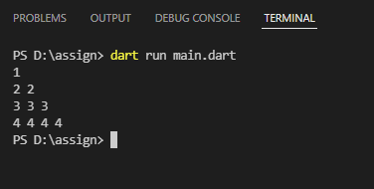

**Write a program to find out the sum of series.**

**Test Data:**

**The Sum of series is:**

**1 + 5 + 9 + 13 + 17 + 21 + 25 + 29 + 33 + 37 = 190**

void main() {

var sum=[1 , 5 , 9 ,13 ,17 ,21 ,25 ,29 ,33 ,37].reduce((value, element) => value+element);

print("Sum = $sum");

}

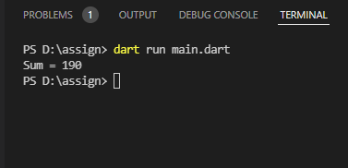

**Write a program to find majority element of an array.**

**The given array is: 1 3 3 7 4 3 2 3 3**

import 'dart:io';

void main() {

List<int> arr=[1 ,3 ,3 ,7,4,3,2,3,3];

int n=arr.length;

int maxCount = 0;

int index = -1;

for (int i = 0; i < n; i++) {

int count = 0;

for (int j = 0; j < n; j++)

{

if (arr[i] == arr[j])

{

count++;

}

}

if (count > maxCount)

{

maxCount = count;

index = i;

}

}

if (maxCount > n / 2)

{ print("Matority Element:${arr[index]}");}

else

{ print("No Majority Element");}

}

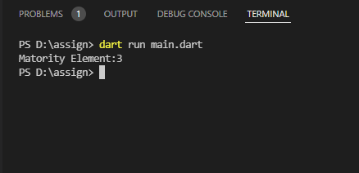

**Write a program to find the minimum distance between two numbers**

**in a given array**

**The given array is: 7 9 5 11 7 4 12 6 2 11**

**Write a program to check whether a character is an alphabet, digit or**

**special character.**

import 'dart:io';

void main() {

print("Enter any Single Character Only:For Alphabets (a-z / A-Z) or For Digits(0-9) or Any Special Character");

var char=stdin.readLineSync();

if((char=="a-z" )|| char=="A-Z"){

print("Alphabet:$char");

}

else if(char=="0-9"){

print("Digit:$char");

}

else

{

print("Special Character");

}

**}**